**LAB 1**

1. Convert the Calculator[servlet version provided in ZIP file] to MVC 2 use 3 JSPs [ index.jsp, calculator.jsp, result.jsp]. HINT: index.jsp should forward to “private” calculator.
2. Convert the Starbuck’s project provided [Zip file] to MVC 2 using JSPs.

A good goal is to have three JSP pages with respect to choices; index, advice, display (no JavaScript ).

Also update the advice.jsp so that it uses the JSTL forEach for the option list.

1. [Optional]Write an application that generates a random number and compares it to three other randomly generated numbers. There are 3 comparisons:

* First number is less than “control” number
* Second Number is greater than “control” number
* Third Number is equal to the “control” number

If an individual comparison is true, the result is output to the page. If all comparisons fail then all the numbers are output.

The application should reflect an MVC 2 – like architecture…that is a servlet and a JSP.

The comparisons are to be done in the JSP using JSTL logic. In particular, you should use the <c:choose> construct. Also, the results are to be color coded and bold:

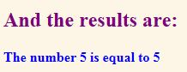

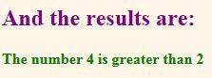

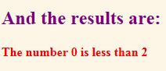

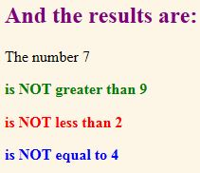

**What to turn in for this lab:**

All the projects/code you have for this lab.